|  |  |
| --- | --- |
| AndroidManifest.xml  <?xml version="1.0" encoding="utf-8"?> <manifest xmlns:android="http://schemas.android.com/apk/res/android"  package="com.example.cameraapplication">   <uses-permission android:name="android.permission.CAMERA"/>  <application  android:allowBackup="true"  android:icon="@mipmap/ic_launcher"  android:label="@string/app_name"  android:roundIcon="@mipmap/ic_launcher_round"  android:supportsRtl="true"  android:theme="@style/Theme.CameraApplication">  <activity  android:name=".MainActivity"  android:exported="true">  <intent-filter>  <action android:name="android.intent.action.MAIN" />   <category android:name="android.intent.category.LAUNCHER" />  </intent-filter>  </activity>  </application>  </manifest>  activity_main.xml  <?xml version="1.0" encoding="utf-8"?> <androidx.constraintlayout.widget.ConstraintLayout xmlns:android="http://schemas.android.com/apk/res/android"  xmlns:app="http://schemas.android.com/apk/res-auto"  xmlns:tools="http://schemas.android.com/tools"  android:layout_width="match_parent"  android:layout_height="match_parent"  android:background="#54A8EC"  android:orientation="vertical"  tools:context=".MainActivity">   <Button  android:id="@+id/idbtn"  android:layout_width="325dp"  android:layout_height="54dp"  android:layout_gravity="center"  android:fontFamily="monospace"  android:onClick="btnClick"  android:text="Launch Camera"  android:textSize="20sp"  app:layout_constraintBottom_toBottomOf="parent"  app:layout_constraintEnd_toEndOf="parent"  app:layout_constraintStart_toStartOf="parent"  app:layout_constraintTop_toTopOf="parent"  app:layout_constraintVertical_bias="0.76" />   <ImageView  android:id="@+id/imageView"  android:layout_width="300dp"  android:layout_height="300dp"  android:layout_gravity="center"  android:background="#ccc"  android:padding="5dp"  app:layout_constraintBottom_toBottomOf="parent"  app:layout_constraintEnd_toEndOf="parent"  app:layout_constraintHorizontal_bias="0.495"  app:layout_constraintStart_toStartOf="parent"  app:layout_constraintTop_toTopOf="parent"  app:layout_constraintVertical_bias="0.308" />  </androidx.constraintlayout.widget.ConstraintLayout> | MainActivity.java  package com.example.cameraapplication; import android.Manifest; import android.app.Activity; import android.content.Intent; import android.content.pm.PackageManager; import android.graphics.Bitmap; import android.provider.MediaStore; //import android.support.v7.app.AppCompatActivity; import android.os.Bundle; import android.view.View; import android.widget.Button; import android.widget.ImageView; import android.widget.Toast;  import androidx.appcompat.app.AppCompatActivity; import androidx.core.app.ActivityCompat;  public class MainActivity extends AppCompatActivity {   Button btn;  private static final int *CAMERA_REQUEST* = 123;  ImageView imageView;     @Override  protected void onCreate(Bundle savedInstanceState) {  super.onCreate(savedInstanceState);  setContentView(R.layout.*activity_main*);  btn = (Button)findViewById(R.id.*idbtn*);  imageView = (ImageView ) findViewById(R.id.*imageView*);    }  public void btnClick(View v){  if(ActivityCompat.*checkSelfPermission*(this,Manifest.permission.*CAMERA*) != PackageManager.*PERMISSION_GRANTED*)  {  Toast.*makeText*(this, "Please grant permission to camera", Toast.*LENGTH_SHORT*).show();  requestPermission();  }  else  {  Intent intent = new Intent(MediaStore.*ACTION_IMAGE_CAPTURE*);  startActivityForResult(intent, *CAMERA_REQUEST*);  }      }  private void requestPermission()  {  ActivityCompat.*requestPermissions*(this,new String[]{Manifest.permission.*CAMERA*},1);  }  public void onActivityResult(int requestCode, int resultCode, Intent data) {  super.onActivityResult(requestCode, resultCode, data);  if (requestCode == *CAMERA_REQUEST* && resultCode == Activity.*RESULT_OK*) {  Bitmap photo = (Bitmap) data.getExtras().get("data");  imageView.setImageBitmap(photo);   }  } }  strings.xml  <resources>  <string name="app_name">CameraApplication</string>  <string name="launch_camera">Launch Camera</string>  <string name="todo">TODO</string> </resources> |

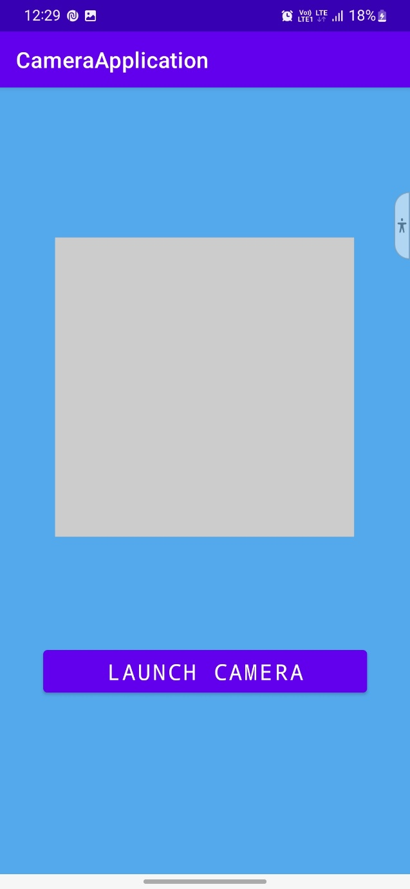

Output

